For this assignment, you will solve problems based on what you have learned in Chapters: GUI Basics, and Event Handling.

Instructions

• Review the chapters from the book and class notes.
• There are 2 questions in this assignment.
• Assignment submitted after due date will not be evaluated.

Due Date and Time: October 30, in class.

Submitting this Assignment

You do not have to submit this assignment. When you have completed solving all questions, show them to the Instructor.

Grading Criteria

There are no marks to this assignment. Questions:
- Write a program that calculates the future value of an investment at a given interest rate for a specified number of years. The formula for the calculation is:

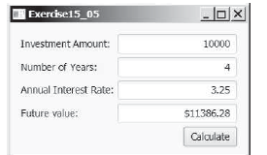

- Write a program to design simple calculator as shown in Figure:

